

Team members:

1-Yahya Snedawi

2-Hasan Habbosh

3-Leqaa Abu-jubbeh

(HOME)

Home page it contains :

1-A navigation bar to navigate between our pages (home, todo list, calculator)

2- A color-picker to change background color for all pages

3- A select to change font family.

4-A footer

5- A simple contact us form with the following inputs:

a. User Name

b. Email

c. Date of birth

d. Phone Number

e. Password

f. three buttons (button to save data on local storage, button to save data on session storage, and button to clear all written input from the form).

g. Checkbox for agreement (should be checked to enable the save-data buttons).

h. Both buttons for saving data will be disabled until the check box is checked.

i. All input has a validation .

Each item on the page is divided into elements, and each element has a specific use.

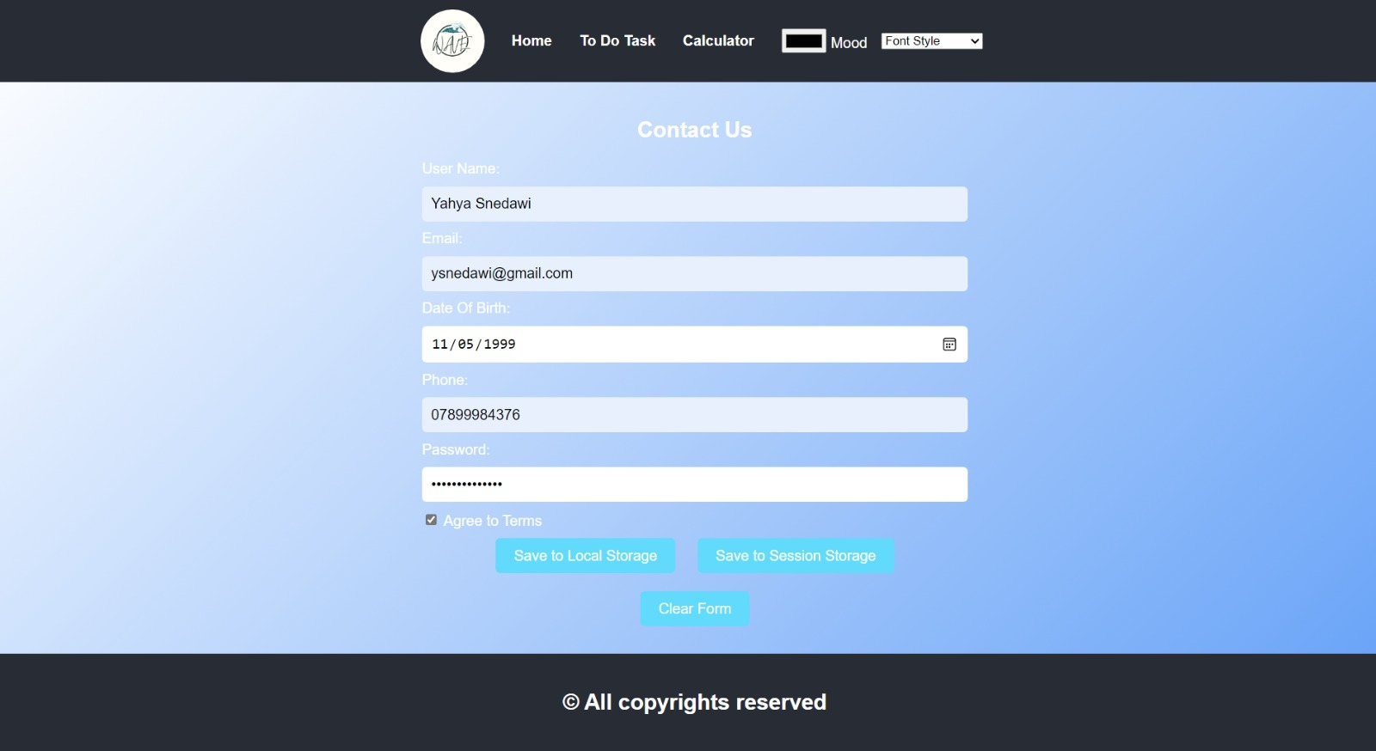

At first, we seemed to talk about the navbar The page is divided into several elements: logo, home, to-do task, calculator, and color mod , font style.



We have made a logo that represents the project, which is [WAVE].

  
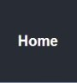

When you press the item, it should take you to the home page.

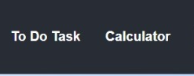

When you press the item, it should take you to the to do task page.

When you press the item, it should take you to the calculator page.

element is used to provide a user interface element that lets a user specify a color.

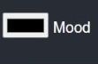

The Font style attribute can control various aspects of font styling, such as font family, size, color, and alignment.

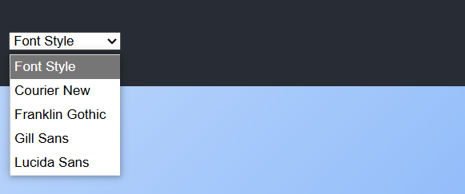

Secondly, we explain the features of the 'Contact Us' section.

A "Contact Us" form is a tool on a website that allows users to send messages, inquiries, or directly to the site owner or organization. Here are some common elements and purposes of a contact us form:

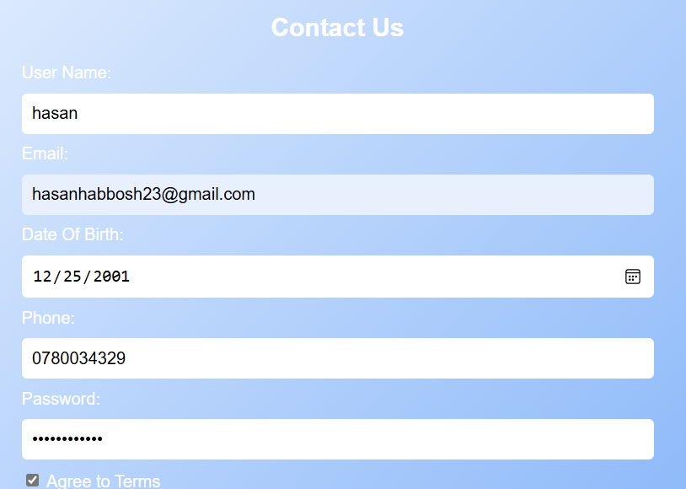

This button saves user data in the browser with no expiration date. The session storage, on the other hand, deletes the data immediately after the session ends.

Button: Refers to a UI element that performs an action, like saving data.

"The 'Clear Form' button deletes the data collected in the form on the user's interface."

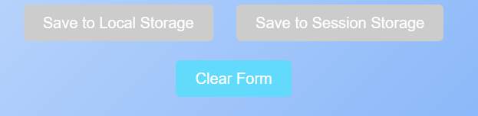

(TO DO TASK)

Second Page (To-Do List) it contains:

1-A navigation bar to navigate between our pages (home, todo list, calculator)

2- A color-picker to change background color for all pages

3- A select to change font family.

4- A footer

5- Input to enter the task.

6- Button to add the task to the local storage.

7- Button to delete all saved tasks.

8- When a task is added, each task will have its own button to delete this certain task.

This is the second page of the project, and it focuses on adding, deleting, and clearing all items, as well as writing tasks for the user.

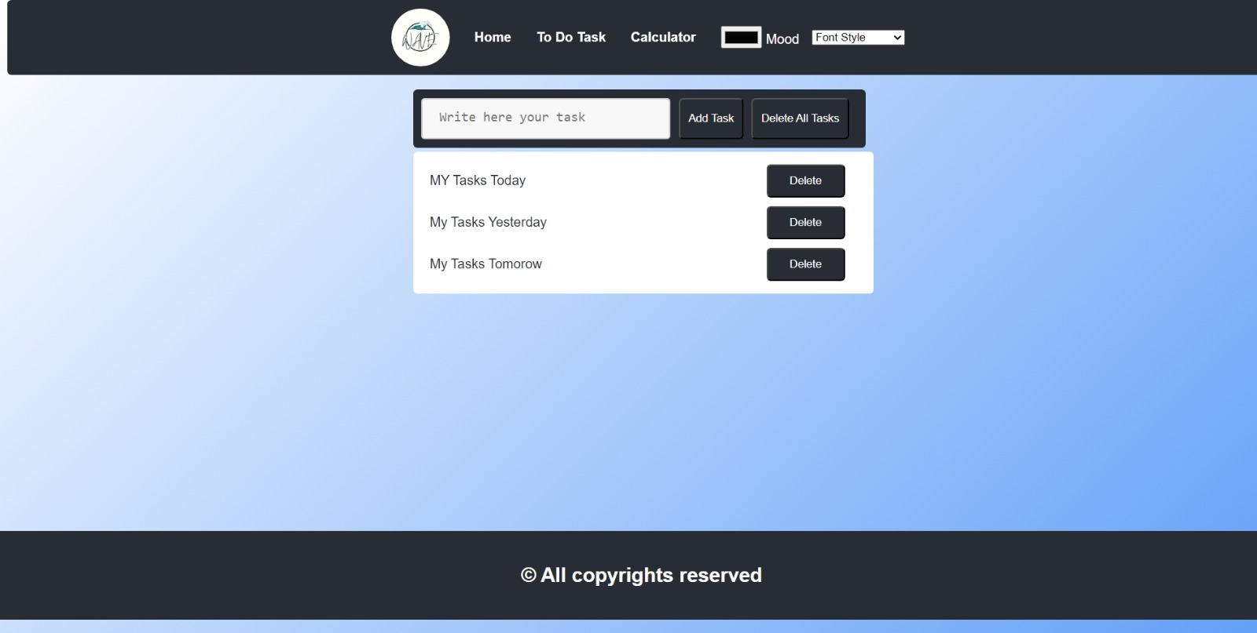

Now, the characteristics are explained through the following image.

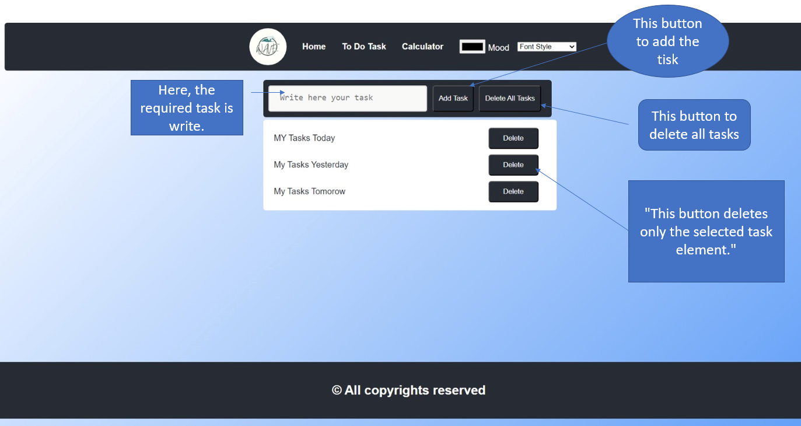

(Calculator)

Third Page: (Calculator) it contains:

1-A navigation bar to navigate between our pages (home, to do list, calculator)

2- A color-picker to change background color for all pages

3- A select to change font family.

4-A footer

5-A simple calculator with the mathematical operations (summation, subtraction, multiplying, dividing, power and factorial) .

Now, the third page features the calculator

performs arithmetic operations like addition, subtraction, multiplication, and division.

Features handling multiple operations, keyboard input support, and error handling.

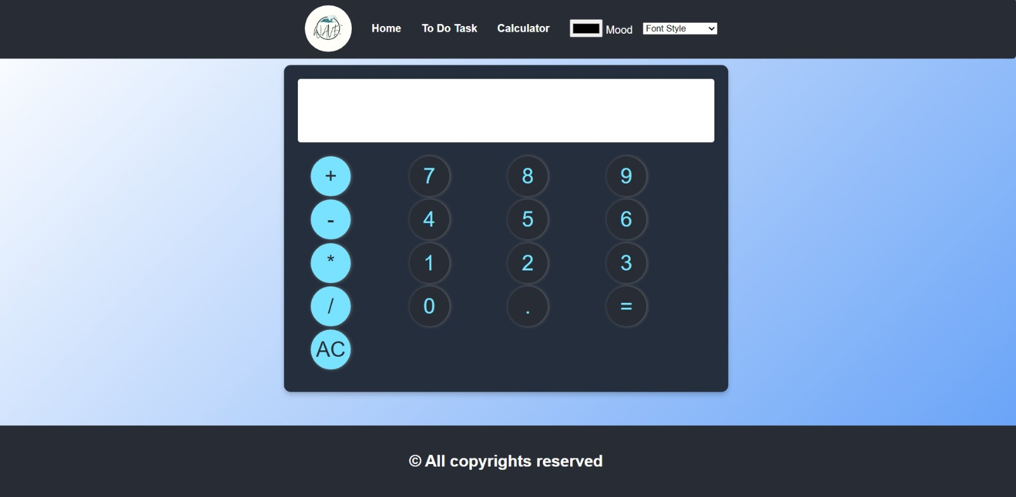

Here’s a picture showing what I can do with the calculator.

